Proceeding With the Repair Functions
- There are eight commands you must enter in sequence to repair any of the issues I noted in the opening of this guide. I will introduce them here, and then show the results graphically in the next six steps. These commands are as follows:
  - C: CD ..
  - C: ATTRIB –H C:\boot.ini
  - C:ATTRIB –S C:\boot.ini
  - C:ATRIB –R C:\boot.ini
  - C: del boot.ini
  - C: BOOTCFG /Rebuild
  - C: CHKDSK /R /F
  - C: FIXBOOT
- To “Go up a directory” in computing is to revert back to the directory above the current folder you’re operating in. If, for example, I’m in the C:WINDOWSSYSTEM32 directory, and I want to get at a file in the WINDOWS directory, I would merely type CD .. and I would be taken out of the SYSTEM32 folder and up one level to WINDOWS. We’re going to do the same thing here from the WINDOWS folder to get to the basic root of C:
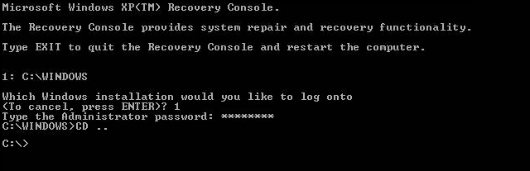
- Now that we are at C: we can begin the process of repairing the operating system
and that begins with modifying the attributes of the BOOT.INI file. Briefly, BOOT.INI controls what operating systems the Windows boot process can see, how to load them, and where they’re located on your disk. We’re going to make sure the file is no longer hidden from our prying eyes, remove the flag that sets it as an undeletable system file, and remove the flag that sets it as a file we can only read, but not write to. To do this, we will issue three commands in this step:
- C:ATTRIB –H C:\BOOT.INI
- C:ATTRIB –R C:\BOOT.INI
- C:ATTRIB –S C:\BOOT.INI
to remove the Hidden, System and Read Only flags.
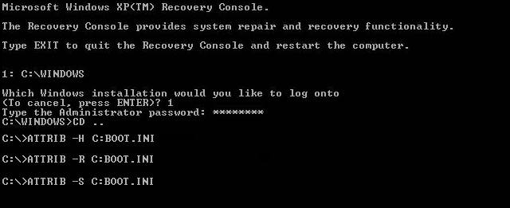
- Now that we’ve modified the attributes for the BOOT.INI file, it’s up for deletion.
the syntax for it is simple: { DEL | FILE NAME }, e.g., C:DEL BOOT.INI deletes the BOOT.INI file.
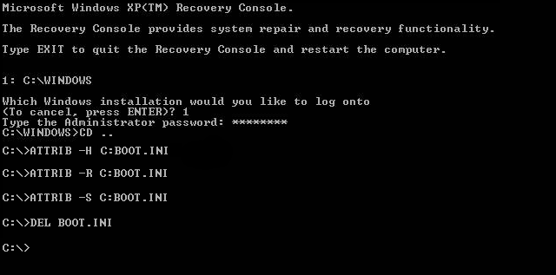
- Now for the most important step of our process, the BOOTCFG /REBUILD
command which searches for pre-existing installations of Windows XP and rebuilds sundry essential components of the Windows operating system, recompiles the BOOT.INI file and corrects a litany of common Windows errors. It is very important that you do one or both of the following two things: First, every Windows XP owner must use /FASTDETECT as an OS Load Option when the rebuild process is finalizing. Secondly, if you are the owner of a CPU featuring Intel’s XD or AMD’s NX buffer overflow protection, you must also use /NOEXECUTE=OPTIN as an OS Load Option. I will demonstrate both commands for the purpose of this guide, but do not set NOEXECUTE as a load option if you do not own one of these CPUs. For the “Enter Load Identifier” portion of this command, you should enter the name of the operating system you have installed. If, for example, you are using Windows XP Home, you could type “Microsoft Windows XP Home Edition” for the identifier. This gives the process some authenticity, if you’re keen on being a perfectionist.
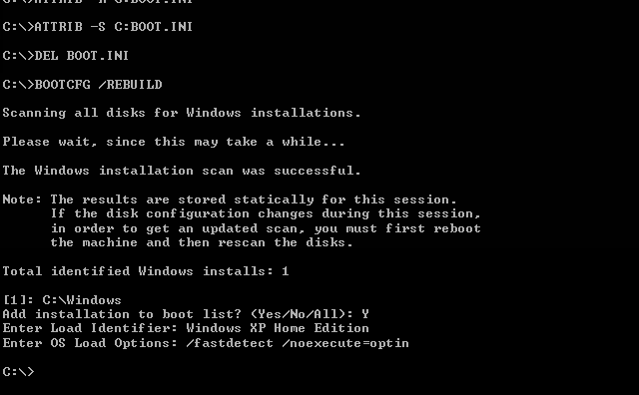
- This step verifies the integrity of the hard drive containing the Windows XP
installation. While this step is not an essential function in our process, it’s still good to be sure that the drive is physically capable of running windows, in that it contains no bad sectors or other corruptions that might be the culprit. No screenshot necessary here! Just type CHKDSK /R /F at the C:> prompt. Let it proceed; it could take in excess of 30 minutes on slower computers, when this is finished move on to the seventh and final step.
- This last step also requires no screenshot. When you are at the C:> prompt,
simply type FIXBOOT. This writes a new boot sector to the hard drive and cleans up all the loose ends we created by rebuilding the BOOT.INI file and the system files. When the Windows Recovery Console asks you if you are “Sure you want to write a new bootsector to the partition C: ?” just hit “Y,” then enter to confirm your decision.

Results and Wrap-Up
It’s time to reboot your PC by typing EXIT in the Windows Recovery Console and confirming the command with a stroke of the enter key. With any luck, your PC will boot successfully into Windows XP as if your various DLL, Hive, EXE and NTLDR errors never existed. You’ve just saved yourself from many hours of work, frustration, potential data loss and shelling out your hard-earned greenbacks at a brick’n’mortar operation.
Keep in mind that this solution is only designed to resolve the issues introduced in the preface if the cause is unrelated to spyware and viruses; while I have had significant luck with rebuilding heavily-infected systems in the method I have described, it is not guaranteed. If you believe your PC has affected one of these symptoms due to spyware or viruses, today’s fastest-growing PC nuisance, please do stop by our Spyware/Virus/Trojan Forum to receive first-class assistance in quarantine, removal and repair. Be sure to read the guidelines of our SVT Forum before posting!

