Albanian Flag Day 2003
Saturday, November 29th

Westin Copley Place Boston
101 Huntington Ave
Boston, MA 02116
(671) 262-9600
www.westin.com

Ticket price:
Adults -- $65.00
Children (12 & under) -- $35.00

Reservation deadline
November 18th, 2003

Please make check payable to:
Flag Day 2003

Mail To:
AANO
P.O. Box 440030
Somerville, MA 02144

For information call:
Albana Orgocka
(617) 629-0563
FlagDay03@juno.com

Proceeds to benefit
The AANO Scholarship Fund
Flag Day 2003 Reservations

November 29, 2003

Reservation deadline 11/18/03

List all names included in reservation:

1. _____________________________
2. _____________________________
3. _____________________________
4. _____________________________
5. _____________________________
6. _____________________________
7. _____________________________
8. _____________________________
9. _____________________________
10._____________________________
(Only ten people per table)

Adults # ____ X $65.00= ________
Children # ____ X $35.00= ________

Formal Attire required

Flag Day 2003

Ticket price includes:

A full course dinner

&

Dancing to traditional and modern Albanian Music

by

“Malli” Band
&
Performances by
Brunilda Sota

Registration: 5:00 PM - 6:00 PM
Cocktails: 6:00 PM - 7:00 PM
Dinner: 7:00 PM sharp
Dancing until 1:00 AM

Flag Day 2003 Advertisement

Booth

Rent a booth ----- $250.00

The booth may be used to display and sell your merchandise. For more information, call
Johanna Adams
at: (781) 272 - 5268

Sponsorship
For other forms of sponsorship call Johanna Adams
at: (781) 608 - 3379

Send payment to:
AANO
P.O Box 440030
Somerville, MA 02144

Westin Hotel Room Reservation:
(617) 262-9600

Public Transportation:
Green Line: Copley station
Orange Line: Back Bay Station
Directions to Parking

By Car From The West
- Follow The Mass Pike *Rt. 90* East Towards Boston and Take Exit 22 *Prudential Center/Copley Square*.

- Bear Right To Copley Square. This Will Bring You Onto Stuart Street.

- At The Second Set Of Lights, Take A Right onto Clarendon Street And Look For The Hard Rock Café on Your Left.

- The Parking Garage *John Hancock Garage* Is ½ Block Beyond The Hard Rock Cafe On The Right-Hand Side Of Clarendon Street.

By Car From The North/South
- Follow Route 93 Towards Boston And Take Exit 26 *Storrow Drive/Cambridge*. Follow Signs Onto Storrow Drive/Back Bay.

- Follow Storrow Drive Signs To Back Bay And Exit At Copley Square *A Left Exit*.
- Turn Right At The Lights Onto Beacon Street.

- At The Second Set Of Lights, Turn Left onto Clarendon Street. Follow Clarendon St. Through *7* Sets Of Lights and Look For The Hard Rock Cafe On Your Left.

- The John Hancock Parking Garage Is 1/2 Block Past the Hard Rock Cafe On The Right.

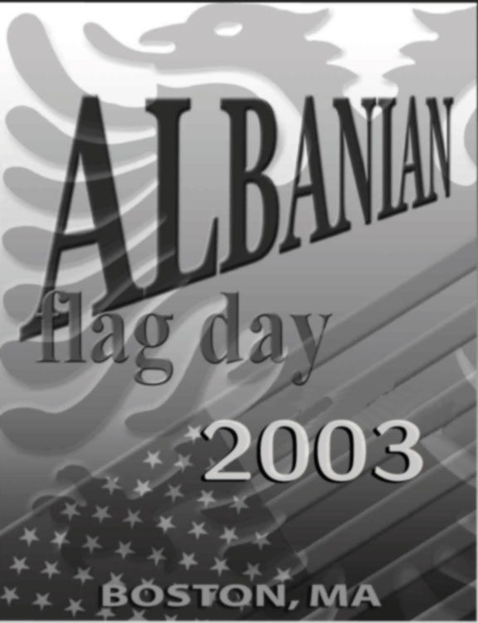

November 29th, 2003
Westin Copley Place, Boston

Sponsored By:

The Boston Chapter
of The Albanian American National Organization (AANO)
&
The Massachusetts Chapter of The National Albanian American Council (NAAC)

